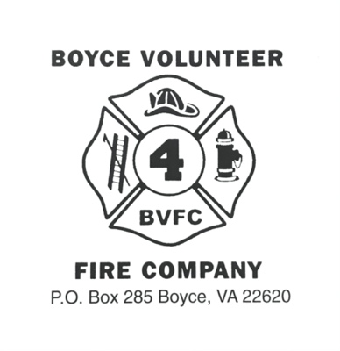
Dear Friends,

Happy 2022 Fall Show Season! The Boyce Volunteer Fire Company would like to invite you to participate in our Fall Bazaar this year.

This year our Fall Bazaar will be held on Saturday, November 12, 2022 with the option of early set-up on Friday, November 11, 2022. A fun day is planned with music, door prizes and quality hand-crafted items to get a jump on the Holiday Shopping Season.

Basic Information

BVFC Fall Bazaar will be held in our Social Hall located at 1 S. Greenway Ave, Boyce, VA 22620.

- The Hall will be open to vendors between 6:00 pm and 8:00 pm on November 11 for early set up and then again at 7:00 am on November 12.
- All vendors must be set up and ready to sell by 8:45 am on Saturday, November 12.
- The show ends at 4:00 pm, however, if we still have shoppers in the building at 4:00 pm, we will stay open to accommodate their shopping needs.
- The cost per table is $30.00 with the option for outdoor space at $25.00.
- The tables, which are provided, are 8 feet long with a brown wooden style top.
- The spaces are available as a 1, 2, or 3 table space.
- If you have any special needs or require electricity, please indicate on your application.
- There will be no refunds after November 5, 2022

The hall is equipped with a sound system for announcements and light holiday music will be playing throughout the day.

The BMW Charge of United Methodist Church Outreach Committee will have a light breakfast and lunch available for sale.

Advertisement will include social media, the Clarke County Monthly newspaper, and running on our Outdoor Sign. Please share and repost our event posts as well as our Facebook Event.

Parking is provided for vendors in the back and on the south side of the building. When setting up, be sure to unload all of your materials and then park your car in those spaces. We will have volunteers to assist and direct the set-up and tear-down process.

There is No Smoking allowed inside the building or the bathrooms. There are designated smoking areas outside on the south side of the building.

NOTE: If you are representing a particular company, be sure to note which company you are representing on your registration. We will attempt, but do not guarantee, you will be the only representative from your company.

Indemnification: The above signed shall be known as: Exhibitor or Vendor. Boyce Volunteer Fire Company shall be known as BVFC for the purposes of this agreement. Exhibitor and/or Vendor agrees to indemnify, defend and hold harmless BVFC, its officers, agents and employees from any claims damages and actions of any kind or nature, whether at law or in equity, arising from or accused by any service/operations of any kind or nature furnished by the Exhibitor and/or Vendor. Vendor acknowledges that it is responsible for any personal injuries or property damage that may occur during the event for any reason and that BVFC will not insure the Vendor for any risks associated with the event. BVFC will not be liable for refunds or any other liabilities whatsoever for the failure to fulfill this contract due to the reasons of the enclosure in which the event is held, being before or during the show, is destroyed by fire, or other calamity, or act of God, public enemy, strikes, statues, ordinances, or legal authority or any other act beyond the control of BVFC that make it impossible or impractical to hold the event. BVFC will not be liable for any damage done by Vendors to public/private property during set-up, tear down and regular operational hours. This includes the operation of any equipment (motorized or non-motorized)

Application Process

Registrations are due no later than October 29, 2022. Once complete, return your application and payment to:

Boyce Volunteer Fire Company
PO Box 285,
Boyce, VA 22620
ATTN: Fall Bazaar

Make checks/money order payable to “Boyce Volunteer Fire Company” and mail your check/money order with completed application to the above address. For your convenience, you can also pay through PayPal using bvfctreas@gmail.com. Be sure to note that you are submitting payment for the 2022 Fall Bazaar, then email your completed application to BoyceFireCo4@gmail.com or “snail mail” to the above address.

BVFC Fall Bazaar Standards

- Boyce Volunteer Fire Company is committed to presenting quality vendors and a community event at our Annual Fall Bazaar.
- You must sell what is represented on your application.
- All vendors must be present to sell their own original work or products.
- Food items may be sold, but not for consumption on the premises. Tastings will be allowed.
- Space requests will be considered but not guaranteed. Corner, wall, and spaces with electricity are limited, so submit your application early.
- This year we are offering outdoor spaces on the North side of the building. These spaces will be set up on the grass between East Main Street and the Social Hall with access from the building and the parking lot.
- SPACES WILL BE RESERVED AS APPLICATIONS AND FEES ARE RECEIVED.
- All vendors will be required to pay their own individual sales tax at the rate of 5.3%. You may obtain the tax form ST-50 at www.tax.virginia.gov .
- Vendors are invited, but not required, to donate a $5-$10 item for a door prize. Door prizes will be drawn every 30 minutes and patrons must be present to win.
- Vendors are provided an 8’ table per space for their displays, but are invited to use their own tables and displays, however, they may not exceed the boundary of their 10’ x 6’ space.
- Indicate if you DO NOT require the provided table in the “Special Needs” section on your application
- Vendors may not tape, tie, secure, or hang any signs or part of their display on the walls or windows.
- Early set-up will be available on Friday November 11 from 6:00 pm – 8:00 pm.
- Saturday set-up will start at 7:00 am and you must be ready to sell by 8:45 am.
- Volunteers will be available to direct and help with set-up and tear-down.
- Vendor booths must remain set up for sale until the close of the show at 4:00 pm.
- Any vendor packing up and leaving prior to the end of the show will be removed from the Vendor List. Exceptions will be considered on a case-by-case basis and/or if the vendor sells out.
- Vendors must remove all trash from their space at the end of the show.
- CONFIRMATION: You will be notified by email, or snail mail if you did not provide an email, of your acceptance and space assignment by October 29, 2022.

If you have any questions, please contact Carol at (703) 470-4236, Cathy at 540-303-5800 or Barbara at (540) 837-2819.

Thank You,

Carol Coffelt
703-470-4236
BVFC Fundraising & Events Chairperson

Boyce Volunteer Fire Company Fall Bazaar Information
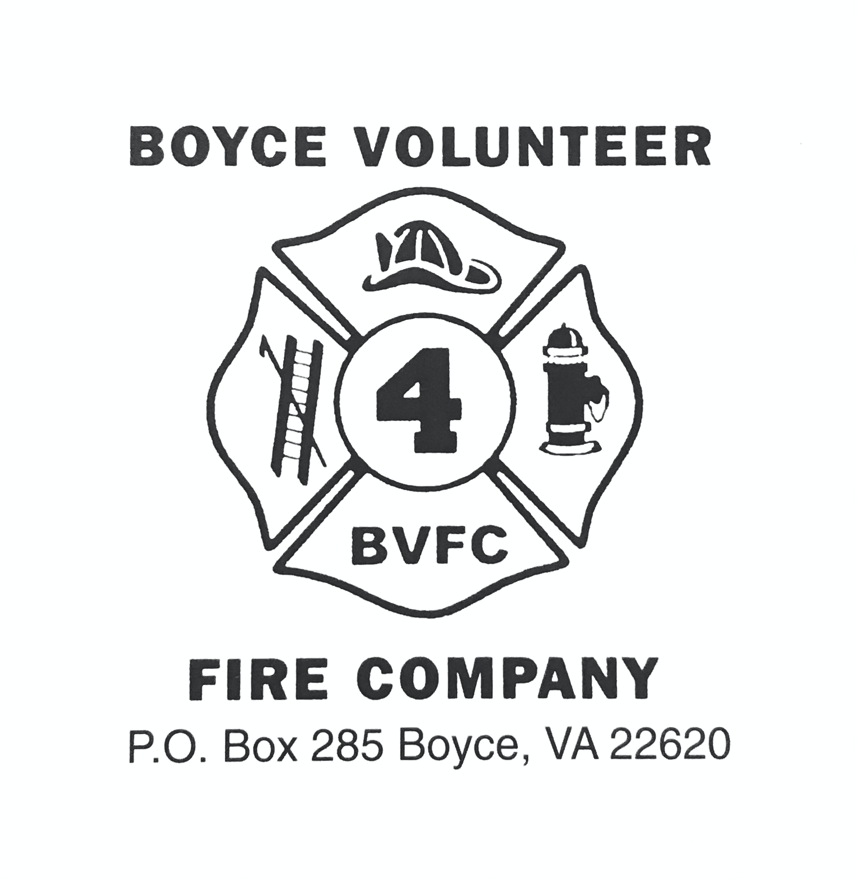

Vendor Information

Name/Company Name:

Address:

Phone: Day: Evening:

Email:

Type of Product: Price range:

Website (n/a if you do not have one):

Facebook and/or other Social Media:

How Many Tables (circle one): 1 / 2 / 3 $30 each Total Due:

Outside spaces/tables: $25 each Total Due:

Electricity (circle one): YES / NO (electricity not available outside)

Special Needs:

By signing this application, you agree to the rules set forth in the attached letter.

Printed Name:

Signature:

Date:

Fall Bazaar, November 12, 2022. Registrations are due on October 29, 2022.
Once complete, return your application and payment to the address below.
PayPal option: bvfctreas@gmail.com

Boyce Volunteer Fire Company
PO Box 285, Boyce, VA 22620
ATTN: Fall Bazaar

If you have any questions, please contact Carol at (703) 470-4236, Cathy at 540-303-5800 or Barbara at (540) 837-2819.

